HUMBER INSTITUTE OF TECHNOLOGY

AND ADVANCED LEARNING

**BUSE 5303 – Big Data 2**

Group Project

Data Visualization for Decision Making

Submitted by: Ansh Gangdev

Deepanshi Garg

Janna Avila

Kapil Sharma

Kivan Ilangakoon

Saransh Vaid

**Video Presentation Link**

<https://drive.google.com/file/d/1mcqZbK2JzDX2t5ApZTjwpDSve5sA1D1C/view>

**RStudio Code**

*#installing and loading packages*

install.packages("dplyr")

install.packages("lubridate")

install.packages("stringr")

install.packages("tidyr")

install.packages("plotly")

install.packages("rnaturalearth")

install.packages("rnaturalearthdata")

install.packages("ggmap")

install.packages("devtools")

install.packages("sf")

devtools::install_github("ropensci/rnaturalearthhires")

remove.packages("tidyverse")

library(plotly)

library(readr)

library(dplyr)

library(lubridate)

library(stringr)

library(ggplot2)

library(tidyr)

library(reshape2)

library(rnaturalearth)

library(sf)

library(rnaturalearthdata)

library(ggmap)

*#------------------------------------------------------------------------------*

*#------------------------------------------------------------------------------*

*#------------------------------------------------------------------------------*

*#importing data files into DFs*

Prosperity_Poverty <- read_csv("C:**\\**Users**\\**deepa**\\**OneDrive**\\**Desktop**\\**Big Data 2**\\**Project**\\**ProsPov.csv")

Prossperty_Unemployment <- read_csv("C:**\\**Users**\\**deepa**\\**OneDrive**\\**Desktop**\\**Big Data 2**\\**Project**\\**ProsUnem.csv")

Health_Life <- read_csv("C:**\\**Users**\\**deepa**\\**OneDrive**\\**Desktop**\\**Big Data 2**\\**Project**\\**HealLif.csv")

Health_Mental <- read_csv("C:**\\**Users**\\**deepa**\\**OneDrive**\\**Desktop**\\**Big Data 2**\\**Project**\\**HealMen.csv")

Social_Belonging <- read_csv("C:**\\**Users**\\**deepa**\\**OneDrive**\\**Desktop**\\**Big Data 2**\\**Project**\\**SocBel.csv")

Environment_Gas <- read_csv("C:**\\**Users**\\**deepa**\\**OneDrive**\\**Desktop**\\**Big Data 2**\\**Project**\\**EnvGas.csv")

Governance_Victim <- read_csv("C:**\\**Users**\\**deepa**\\**OneDrive**\\**Desktop**\\**Big Data 2**\\**Project**\\**GoodVic.csv")

*#Selecting relevant cols for DFs and renaming*

Prosperity_Poverty <- Prosperity_Poverty[, c("REF_DATE", "GEO", "Individual MBM poverty status (7)", "VALUE")]

names(Prosperity_Poverty)[names(Prosperity_Poverty) == 'Individual MBM poverty status (7)'] <- 'CATEGORY'

Prossperty_Unemployment <- Prossperty_Unemployment[, c("REF_DATE", "GEO", "Labour force characteristics", "VALUE")]

names(Prossperty_Unemployment)[names(Prossperty_Unemployment) == 'Labour force characteristics'] <- 'CATEGORY'

Health_Life <- Health_Life[, c("REF_DATE", "GEO", "Age group", "VALUE")]

names(Health_Life)[names(Health_Life) == 'Age group'] <- 'CATEGORY'

Health_Mental <- Health_Mental[, c("REF_DATE", "GEO", "Indicators", "VALUE")]

Social_Belonging <- Social_Belonging[, c("REF_DATE", "GEO", "Indicators", "VALUE")]

names(Environment_Gas)[names(Environment_Gas) == '1990 greenhouse gas emissions (megatonnes of carbon dioxide equivalent)'] <- 'Year_1990'

names(Environment_Gas)[names(Environment_Gas) == '2005 greenhouse gas emissions (megatonnes of carbon dioxide equivalent)'] <- 'Year_2005'

names(Environment_Gas)[names(Environment_Gas) == '2020 greenhouse gas emissions (megatonnes of carbon dioxide equivalent)'] <- 'Year_2020'

names(Environment_Gas)[names(Environment_Gas) == 'Province or territory'] <- 'Province'

names(Governance_Victim)[names(Governance_Victim) == 'Percentage of persons reporting victimization (%)'] <- 'Victimization'

names(Governance_Victim)[names(Governance_Victim) == 'Percentage of persons reporting violent victimization (%)'] <- 'Violent_Victimization'

*#------------------------------------------------------------------------------*

*#------------------------------------------------------------------------------*

*#------------------------------------------------------------------------------*

*#importing data files into DFs*

Prosperity_Poverty <- read_csv("C:**\\**Users**\\**deepa**\\**OneDrive**\\**Desktop**\\**Big Data 2**\\**Project**\\**ProsPov.csv")

Prossperty_Unemployment <- read_csv("C:**\\**Users**\\**deepa**\\**OneDrive**\\**Desktop**\\**Big Data 2**\\**Project**\\**ProsUnem.csv")

Health_Life <- read_csv("C:**\\**Users**\\**deepa**\\**OneDrive**\\**Desktop**\\**Big Data 2**\\**Project**\\**HealLif.csv")

Health_Mental <- read_csv("C:**\\**Users**\\**deepa**\\**OneDrive**\\**Desktop**\\**Big Data 2**\\**Project**\\**HealMen.csv")

Social_Belonging <- read_csv("C:**\\**Users**\\**deepa**\\**OneDrive**\\**Desktop**\\**Big Data 2**\\**Project**\\**SocBel.csv")

Environment_Gas <- read_csv("C:**\\**Users**\\**deepa**\\**OneDrive**\\**Desktop**\\**Big Data 2**\\**Project**\\**EnvGas.csv")

Governance_Victim <- read_csv("C:**\\**Users**\\**deepa**\\**OneDrive**\\**Desktop**\\**Big Data 2**\\**Project**\\**GoodVic.csv")

*#Selecting relevant cols for DFs and renaming*

Prosperity_Poverty <- Prosperity_Poverty[, c("REF_DATE", "GEO", "Individual MBM poverty status (7)", "VALUE")]

names(Prosperity_Poverty)[names(Prosperity_Poverty) == 'Individual MBM poverty status (7)'] <- 'CATEGORY'

Prossperty_Unemployment <- Prossperty_Unemployment[, c("REF_DATE", "GEO", "Labour force characteristics", "VALUE")]

names(Prossperty_Unemployment)[names(Prossperty_Unemployment) == 'Labour force characteristics'] <- 'CATEGORY'

Health_Life <- Health_Life[, c("REF_DATE", "GEO", "Age group", "VALUE")]

names(Health_Life)[names(Health_Life) == 'Age group'] <- 'CATEGORY'

Health_Mental <- Health_Mental[, c("REF_DATE", "GEO", "Indicators", "VALUE")]

Social_Belonging <- Social_Belonging[, c("REF_DATE", "GEO", "Indicators", "VALUE")]

names(Environment_Gas)[names(Environment_Gas) == '1990 greenhouse gas emissions (megatonnes of carbon dioxide equivalent)'] <- 'Year_1990'

names(Environment_Gas)[names(Environment_Gas) == '2005 greenhouse gas emissions (megatonnes of carbon dioxide equivalent)'] <- 'Year_2005'

names(Environment_Gas)[names(Environment_Gas) == '2020 greenhouse gas emissions (megatonnes of carbon dioxide equivalent)'] <- 'Year_2020'

names(Environment_Gas)[names(Environment_Gas) == 'Province or territory'] <- 'Province'

names(Governance_Victim)[names(Governance_Victim) == 'Percentage of persons reporting victimization (%)'] <- 'Victimization'

names(Governance_Victim)[names(Governance_Victim) == 'Percentage of persons reporting violent victimization (%)'] <- 'Violent_Victimization'

*#splitting DF into 3 DFs*

Prosperity_Poverty1 <- Prosperity_Poverty[Prosperity_Poverty$CATEGORY %**in**% c("Total - Individual MBM poverty status"), ]

Prosperity_Poverty2 <- Prosperity_Poverty[Prosperity_Poverty$CATEGORY %**in**% c("In poverty"), ]

Prosperity_Poverty3 <- Prosperity_Poverty[Prosperity_Poverty$CATEGORY %**in**% c("Not in poverty"), ]

*#assigning common ID so the DFs can now be merged*

Prosperity_Poverty1 <- cbind(ID = 1:nrow(Prosperity_Poverty1), Prosperity_Poverty1)

Prosperity_Poverty2 <- cbind(ID = 1:nrow(Prosperity_Poverty2), Prosperity_Poverty2)

Prosperity_Poverty3 <- cbind(ID = 1:nrow(Prosperity_Poverty3), Prosperity_Poverty3)

*#merging the 3 DFs by ID's*

Prosperity_Poverty4 <- merge(Prosperity_Poverty1, Prosperity_Poverty2, by = c("ID"))

Prosperity_Poverty5 <- merge(Prosperity_Poverty3, Prosperity_Poverty4, by = c("ID"))

*#Rename*

names(Prosperity_Poverty5)[names(Prosperity_Poverty5) == 'VALUE'] <- 'NOT_IN_POVERTY'

names(Prosperity_Poverty5)[names(Prosperity_Poverty5) == 'VALUE.x'] <- 'TOTAL'

names(Prosperity_Poverty5)[names(Prosperity_Poverty5) == 'VALUE.y'] <- 'IN_POVERTY'

*#Selecting relevant cols for DFs and renaming*

Prosperity_Poverty6 <- Prosperity_Poverty5[, c("REF_DATE", "GEO", "TOTAL", "NOT_IN_POVERTY", "IN_POVERTY")]

*#splitting DF into 2 DFs*

Prossperty_Unemployment1 <- Prossperty_Unemployment[Prossperty_Unemployment$CATEGORY %**in**% c("Population"), ]

Prossperty_Unemployment2 <- Prossperty_Unemployment[Prossperty_Unemployment$CATEGORY %**in**% c("Unemployment rate"), ]

*#assigning common ID so the DFs can now be merged*

Prossperty_Unemployment1 <- cbind(ID = 1:nrow(Prossperty_Unemployment1), Prossperty_Unemployment1)

Prossperty_Unemployment2 <- cbind(ID = 1:nrow(Prossperty_Unemployment2), Prossperty_Unemployment2)

*#merging the 3 DFs by ID's*

Prossperty_Unemployment3 <- merge(Prossperty_Unemployment1, Prossperty_Unemployment2, by = c("ID"))

*#Rename*

names(Prossperty_Unemployment3)[names(Prossperty_Unemployment3) == 'REF_DATE.x'] <- 'REF_DATE'

names(Prossperty_Unemployment3)[names(Prossperty_Unemployment3) == 'GEO.x'] <- 'GEO'

names(Prossperty_Unemployment3)[names(Prossperty_Unemployment3) == 'VALUE.x'] <- 'POPULATION'

names(Prossperty_Unemployment3)[names(Prossperty_Unemployment3) == 'VALUE.y'] <- 'UNEMPLOYMENT_RATE'

*#Selecting relevant cols for DFs and renaming*

Prossperty_Unemployment4 <- Prossperty_Unemployment3[, c("REF_DATE", "GEO", "POPULATION", "UNEMPLOYMENT_RATE")]

*#splitting DF into 3 DFs*

Social_Belonging1 <- Social_Belonging[Social_Belonging$Indicators %**in**% c("Very strong or somewhat strong sense of belonging to local community"), ]

Social_Belonging2 <- Social_Belonging[Social_Belonging$Indicators %**in**% c("Somewhat weak or very weak sense of belonging to local community"), ]

Social_Belonging3 <- Social_Belonging[Social_Belonging$Indicators %**in**% c("No opinion on sense of belonging to local community"), ]

*#assigning common ID so the DFs can now be merged*

Social_Belonging1 <- cbind(ID = 1:nrow(Social_Belonging1), Social_Belonging1)

Social_Belonging2 <- cbind(ID = 1:nrow(Social_Belonging2), Social_Belonging2)

Social_Belonging3 <- cbind(ID = 1:nrow(Social_Belonging3), Social_Belonging3)

*#merging the 3 DFs by ID's*

Social_Belonging4 <- merge(Social_Belonging1, Social_Belonging2, by = c("ID"))

Social_Belonging5 <- merge(Social_Belonging3, Social_Belonging4, by = c("ID"))

*#Rename*

names(Social_Belonging5)[names(Social_Belonging5) == 'VALUE'] <- 'NO_OPINION'

names(Social_Belonging5)[names(Social_Belonging5) == 'VALUE.x'] <- 'VERYSTRONG_SOMEWHATSTRONG'

names(Social_Belonging5)[names(Social_Belonging5) == 'VALUE.y'] <- 'SOMEWHATWEAK_VERYWEAK'

*#Selecting relevant cols for DFs and renaming*

Social_Belonging6 <- Social_Belonging5[, c("REF_DATE", "GEO", "VERYSTRONG_SOMEWHATSTRONG", "SOMEWHATWEAK_VERYWEAK", "NO_OPINION")]

*#splitting DF into 3 DFs*

Health_Mental1 <- Health_Mental[Health_Mental$Indicators %**in**% c("Excellent or very good perceived mental health"), ]

Health_Mental2 <- Health_Mental[Health_Mental$Indicators %**in**% c("Good perceived mental health"), ]

Health_Mental3 <- Health_Mental[Health_Mental$Indicators %**in**% c("Fair or poor perceived mental health"), ]

*#assigning common ID so the DFs can now be merged*

Health_Mental1 <- cbind(ID = 1:nrow(Health_Mental1), Health_Mental1)

Health_Mental2 <- cbind(ID = 1:nrow(Health_Mental2), Health_Mental2)

Health_Mental3 <- cbind(ID = 1:nrow(Health_Mental3), Health_Mental3)

*#merging the 3 DFs by ID's*

Health_Mental4 <- merge(Health_Mental1, Health_Mental2, by = c("ID"))

Health_Mental5 <- merge(Health_Mental3, Health_Mental4, by = c("ID"))

*#Rename*

names(Health_Mental5)[names(Health_Mental5) == 'VALUE'] <- 'FAIR_OR_POOR'

names(Health_Mental5)[names(Health_Mental5) == 'VALUE.x'] <- 'EXCELLENT_OR_VERYGOOD'

names(Health_Mental5)[names(Health_Mental5) == 'VALUE.y'] <- 'GOOD'

*#Selecting relevant cols for DFs and renaming*

Health_Mental5 <- Health_Mental5[, c("REF_DATE", "GEO", "EXCELLENT_OR_VERYGOOD", "GOOD", "FAIR_OR_POOR")]

*#splitting DF into 2 DFs*

Health_Life1 <- Health_Life[Health_Life$CATEGORY %**in**% c("At birth"), ]

Health_Life2 <- Health_Life[Health_Life$CATEGORY %**in**% c("At age 65"), ]

*#assigning common ID so the DFs can now be merged*

Health_Life1 <- cbind(ID = 1:nrow(Health_Life1), Health_Life1)

Health_Life2 <- cbind(ID = 1:nrow(Health_Life2), Health_Life2)

*#merging the 3 DFs by ID's*

Health_Life3 <- merge(Health_Life1, Health_Life2, by = c("ID"))

*#Rename*

names(Health_Life3)[names(Health_Life3) == 'REF_DATE.x'] <- 'REF_DATE'

names(Health_Life3)[names(Health_Life3) == 'GEO.x'] <- 'GEO'

names(Health_Life3)[names(Health_Life3) == 'VALUE.x'] <- 'AT_BIRTH'

names(Health_Life3)[names(Health_Life3) == 'VALUE.y'] <- 'AT_AGE65'

*#Selecting relevant cols for DFs and renaming*

Health_Life4 <- Health_Life3[, c("REF_DATE", "GEO", "AT_BIRTH", "AT_AGE65")]

*#---------------------------------------------------------------*

*#---------------------------------------------------------------*

*#---------------------------------------------------------------*

*#Prosperity Poverty --------------------------------------------*

df1 <- Prosperity_Poverty6[, c("GEO", "TOTAL", "IN_POVERTY", "NOT_IN_POVERTY")]

df1$POVERTY_RATE <- (df1$IN_POVERTY / df1$TOTAL) * 100

*#Creating another dummy for sorting GEO by Alphabetical order*

df1_S <- df1

*#Sorting GEO by Alphabetical order*

df1_Sorted <- df1_S[order(df1_S$GEO), ]

*#rounding off average rate columns to 2 DP*

df1_Sorted <- df1_Sorted %>%

mutate_if(**is**.numeric,

round, digits = 2)

*# Create named vector of province abbreviations*

PROVINCE_drop <- c(

"Newfoundland and Labrador" = "NL",

"Prince Edward Island" = "PE",

"Nova Scotia" = "NS",

"New Brunswick" = "NB",

"Quebec" = "QC",

"Ontario" = "ON",

"Manitoba" = "MB",

"Saskatchewan" = "SK",

"Alberta" = "AB",

"British Columbia" = "BC"

)

df1_Sorted <- df1_Sorted %>%

mutate(PROVINCE_drop = PROVINCE_drop[GEO])

df1B <- df1_Sorted[, c("PROVINCE_drop", "TOTAL", "IN_POVERTY", "NOT_IN_POVERTY", "POVERTY_RATE")]

df1C <- df1B

*#--------------------------------------------------------*

*#--------------------------------------------------------*

*#--------------------------------------------------------*

*#Renaming the PROVINCE_drop to postal for merging the dataframe*

names(df1C)[names(df1C) == 'PROVINCE_drop'] <- 'postal'

*# load the data*

canada_provinces <- ne_states(country = "canada", returnclass = "sf")

*#1mturkData <- read.csv("alldata2.csv", header = TRUE)*

*#Creating dummy*

canada_provincesA <- canada_provinces

*#Merging the data to have same number of rows*

*#merged_data <- merge(canada_provincesA, df1BSorted, by = "postal", all.x = TRUE)*

merged_data <- merge(canada_provincesA, df1C, by = c("postal"))

*#binding the data since it has same number of rows now*

df1D <- cbind(df1C, merged_data)

*#dropping one of the postal code column and creating a new dataframe*

df1E <- df1D[, -6]

*#--------------------------------------------------------*

*#--------------------------------------------------------*

*#--------------------------------------------------------*

*# convert df1E to sf object*

df1E_sf <- st_as_sf(df1E, coords = c("longitude", "latitude"), crs = 4326)

*# plot choropleth map*

ggplot() +

geom_sf(data = df1E_sf, aes(fill = POVERTY_RATE)) +

scale_fill_gradient(low = "white", high = "red", na.value = "grey") +

theme_void()

*#--------------------------------------------------------*

*#--------------------------------------------------------*

*#--------------------------------------------------------*

library(plotly)

library(sf)

*#Prosperity Unemployment Rate --------------------------------------------*

df2 <- Prossperty_Unemployment4[, c("GEO", "POPULATION", "UNEMPLOYMENT_RATE")]

*# Add new column with province abbreviations to existing data frame*

df2 <- df2 %>%

mutate(PROVINCE = PROVINCE_drop[GEO])

Prossperty_Unem <- read_csv("ProsUnem1.csv")

df2A <- Prossperty_Unem[, c("GEO", "VALUE")]

names(df2A)[names(df2A) == 'VALUE'] <- 'UNEMPLOYMENT'

df2B <- cbind(df2, df2A$UNEMPLOYMENT)

names(df2B)[names(df2B) == 'df2A$UNEMPLOYMENT'] <- 'UNEMPLOYMENT'

*#df2B$POVERTY_RATE <- (df1$IN_POVERTY / df1$TOTAL) * 100*

df2C <- df2B[, c("PROVINCE", "POPULATION", "UNEMPLOYMENT_RATE")]

*# Create the plot*

ggplot(df2C, aes(x = PROVINCE, y = POPULATION)) +

geom_bar(stat = "identity", fill = "#FA9203") +

geom_text(aes(label = paste0(UNEMPLOYMENT_RATE, "%")), vjust = -0.5, size = 4) +

labs(x = "Province", y = "Population (Thousands)", title = "Population vs Unemployment Rate by Province") +

theme(plot.title = element_text(hjust = 0.5, margin = margin(b = 20), size = 18))

ggsave("Population vs Unemployment Rate by Province.jpeg", width = 8, height = 6, dpi = 300)

*#Health-adjusted life expectancy --------------------------------------------*

df3 <- Health_Life4

*# Add new column with province abbreviations to existing data frame*

df3 <- df3 %>%

mutate(PROVINCE = PROVINCE_drop[GEO])

df3A <- df3[, c("PROVINCE", "AT_BIRTH", "AT_AGE65")]

df3B <- df3A %>%

select(PROVINCE, AT_BIRTH, AT_AGE65) %>%

pivot_longer(cols = c(AT_BIRTH, AT_AGE65),

names_to = "Variable", values_to = "Value") %>%

mutate(Variable = factor(Variable, levels = c("AT_BIRTH", "AT_AGE65")))

*# create grouped bar chart*

ggplot(df3B, aes(x = PROVINCE, y = Value, fill = Variable)) +

geom_bar(position = "dodge", stat = "identity") +

xlab("Province") +

ylab("Years") + *# Change y-axis label*

ggtitle("Health-adjusted life expectancy") +

theme_classic() +

scale_fill_discrete(name = "Year") +

labs(fill = "Year") +

scale_fill_manual(values = c("#E14F08", "#6D0E4E"),

guide = guide_legend(title = "Health-adjusted life expectancy")) +

theme(plot.title = element_text(hjust = 0.5, margin = margin(b = 20), size = 18))

ggsave("Health-adjusted life expectancy.jpeg", width = 8, height = 6, dpi = 1080)

*#Health-Perceived mental health --------------------------------------------*

df4 <- Health_Mental5

*# Add new column with province abbreviations to existing data frame*

df4 <- df4 %>%

mutate(PROVINCE = PROVINCE_drop[GEO])

df4A <- df4[, c("PROVINCE", "EXCELLENT_OR_VERYGOOD", "GOOD", "FAIR_OR_POOR")]

df4B <- df4A %>%

select(PROVINCE, EXCELLENT_OR_VERYGOOD, GOOD, FAIR_OR_POOR) %>%

pivot_longer(cols = c(EXCELLENT_OR_VERYGOOD, GOOD, FAIR_OR_POOR),

names_to = "Variable", values_to = "Value") %>%

mutate(Variable = factor(Variable, levels = c("EXCELLENT_OR_VERYGOOD", "GOOD", "FAIR_OR_POOR")))

ggplot(df4B, aes(x = Value, y = reorder(PROVINCE, Value), fill = Variable)) +

geom_col(position = "stack") +

geom_text(aes(label = paste0(round(Value), "%")), position = position_stack(vjust = 0.5)) +

labs(x = "Percentage", y = "Province",

title = "Perceived Mental Health") +

scale_fill_manual(values = c("#0072B2", "#462969", "#B31A15"),

name = "Health Perception") +

theme(plot.title = element_text(hjust = 0.5, margin = margin(b = 20), size = 18))

ggsave("Perceived Mental Health.jpeg", width = 8, height = 6, dpi = 1080)

*#Society - Sense of belonging to local community ---------------------------*

df5 <- Social_Belonging6

df5 <- df5 %>%

mutate(PROVINCE = PROVINCE_drop[GEO])

df5A <- df5[, c("PROVINCE", "VERYSTRONG_SOMEWHATSTRONG", "SOMEWHATWEAK_VERYWEAK", "NO_OPINION")]

df5B <- df5A %>%

select(PROVINCE, VERYSTRONG_SOMEWHATSTRONG, SOMEWHATWEAK_VERYWEAK, NO_OPINION) %>%

pivot_longer(cols = c(VERYSTRONG_SOMEWHATSTRONG, SOMEWHATWEAK_VERYWEAK, NO_OPINION),

names_to = "Variable", values_to = "Value") %>%

mutate(Variable = factor(Variable, levels = c("VERYSTRONG_SOMEWHATSTRONG", "SOMEWHATWEAK_VERYWEAK", "NO_OPINION")))

ggplot(df5B, aes(x = Value, y = reorder(PROVINCE, Value), fill = Variable)) +

geom_col(position = "stack") +

geom_text(aes(label = paste0(round(Value), "%")), position = position_stack(vjust = 0.5)) +

labs(x = "Percentage", y = "Province",

title = "Sense of Belonging to Society") +

scale_fill_manual(values = c("#FA9203", "#0072B2", "#B31A15"),

name = "Belonging Perception") +

theme(plot.title = element_text(hjust = 0.5, margin = margin(b = 20), size = 18))

ggsave("Sense of Belonging to Society.jpeg", width = 8, height = 6, dpi = 1080)

*#Environment - Greenhouse Gas Emissions ------------------------------------*

df6 <- Environment_Gas

*# drop last 3 rows*

df6 <- head(df6, -3)

*#add province abbr*

df6$Abbr <- c("NL", "PE", "NS", "NB", "QC", "ON", "MB", "SK", "AB", "BC")

df6A <- df6[, c("Abbr", "Year_1990", "Year_2005", "Year_2020")]

names(df6A)[names(df6A) == 'Abbr'] <- 'PROVINCE'

df6A$Year_1990 <- **as**.numeric(df6A$Year_1990)

df6B <- df6A %>%

select(PROVINCE, Year_1990, Year_2005, Year_2020) %>%

pivot_longer(cols = c(Year_1990, Year_2005, Year_2020),

names_to = "Variable", values_to = "Value") %>%

mutate(Variable = factor(Variable, levels = c("Year_1990", "Year_2005", "Year_2020")))

*# create grouped bar chart*

ggplot(df6B, aes(x = PROVINCE, y = Value, fill = Variable)) +

geom_bar(position = "dodge", stat = "identity") +

xlab("Province") +

ylab("Emissions (CO2 Mt)") + *# Change y-axis label*

ggtitle("Greenhouse Gas Emission") +

theme_classic() +

scale_fill_discrete(name = "Year") +

labs(fill = "Year") + *# Change legend title (alternative method)*

scale_fill_manual(values = c("#E14F08", "#462969", "#FA9203"),

guide = guide_legend(title = "Greenhouse Gas Emission")) +

theme(plot.title = element_text(hjust = 0.5, margin = margin(b = 20), size = 18))

ggsave("Greenhouse Gas Emission.jpeg", width = 8, height = 6, dpi = 1080)

*#Good Governance - Personal Safety ------------------------------------*

df7 <- Governance_Victim

*# drop last 3 rows and top row*

df7 <- head(df7, -3)

df7 <- slice(df7, -1)

*#add province abbr*

df7$Abbr <- c("NL", "PE", "NS", "NB", "QC", "ON", "MB", "SK", "AB", "BC")

df7A <- df7[, c("Abbr", "Victimization", "Violent_Victimization")]

names(df7A)[names(df7A) == 'Abbr'] <- 'PROVINCE'

df7A

my_colors <- c("#E69F00", "#ff6e40", "#009E73", "#F0E442", "#0072B2", "#D55E00", "#CC79A7","#26495c", "#c4a35a", "#c66b3d")

ggplot(df7A, aes(x = Victimization, y = Violent_Victimization, color = PROVINCE)) +

geom_point(size = 5, aes(color = PROVINCE)) +

geom_text(aes(label = PROVINCE), size = 3, vjust = 2, color = "black") +

labs(title = "Reports Made of Violent and Non-Violent Victimization", x = "Non-Violent", y = "Violent") +

theme(plot.title = element_text(hjust = 0.5, margin = margin(b = 20), size = 15)) +

scale_color_manual(values = my_colors) +

guides(color = "none")

ggsave("Reports Made of Violent and Non-Violent Victimization.jpeg", width = 8, height = 6, dpi = 1080)

*############################################################################*

*############################################################################*

*############################################################################*

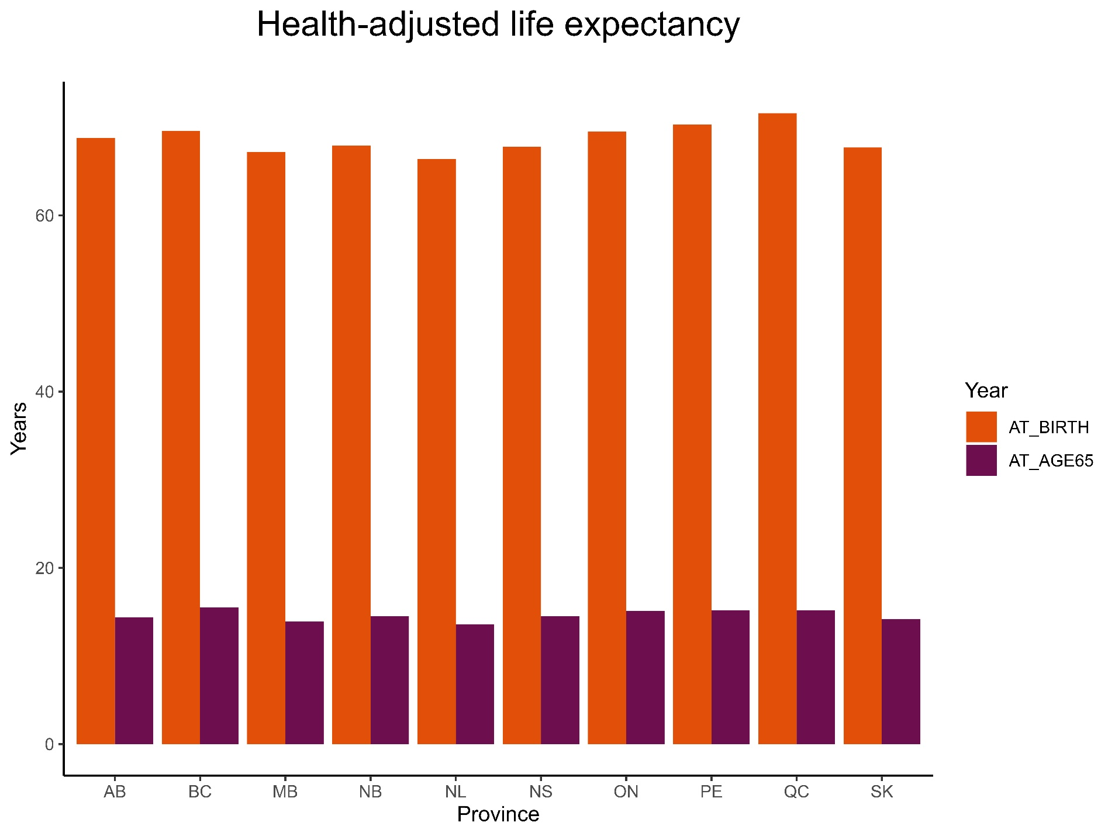

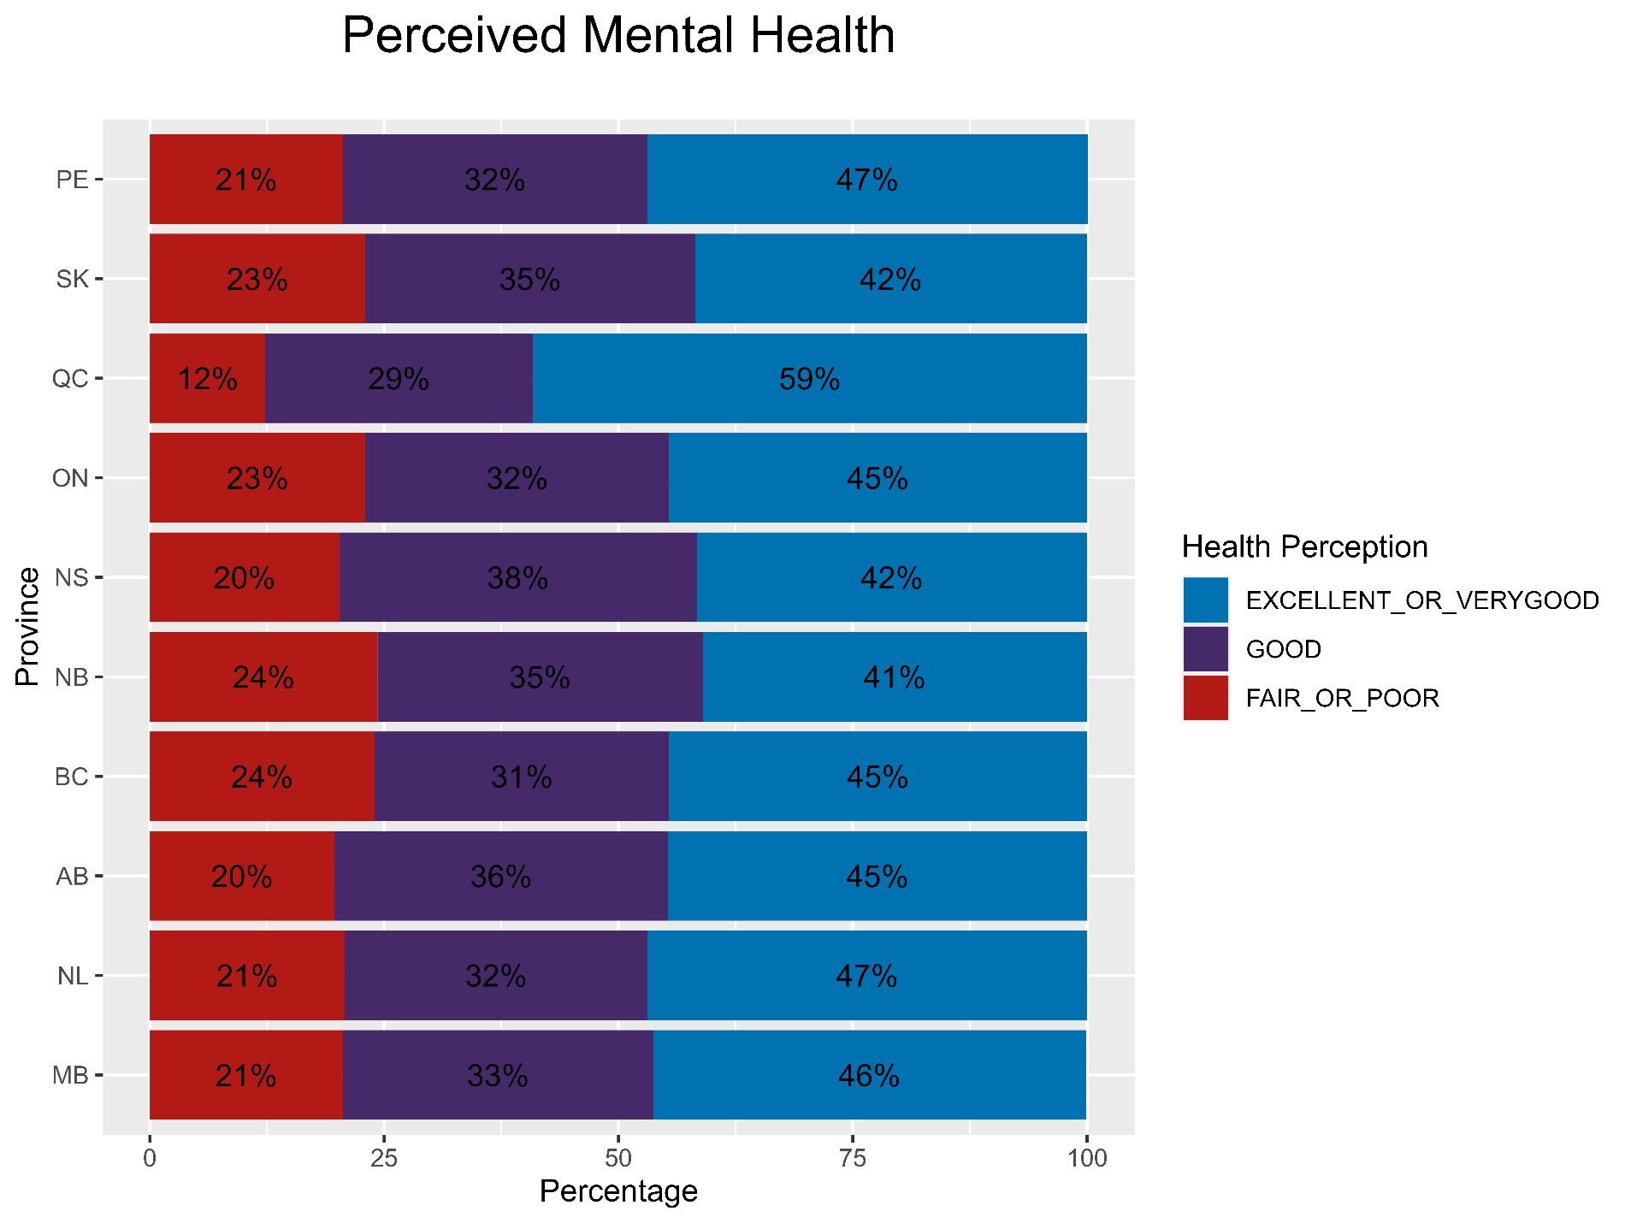

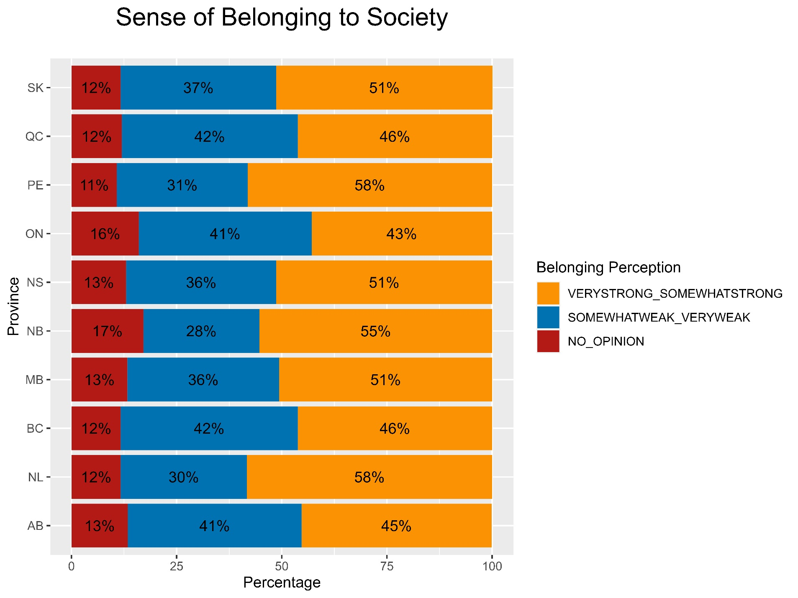

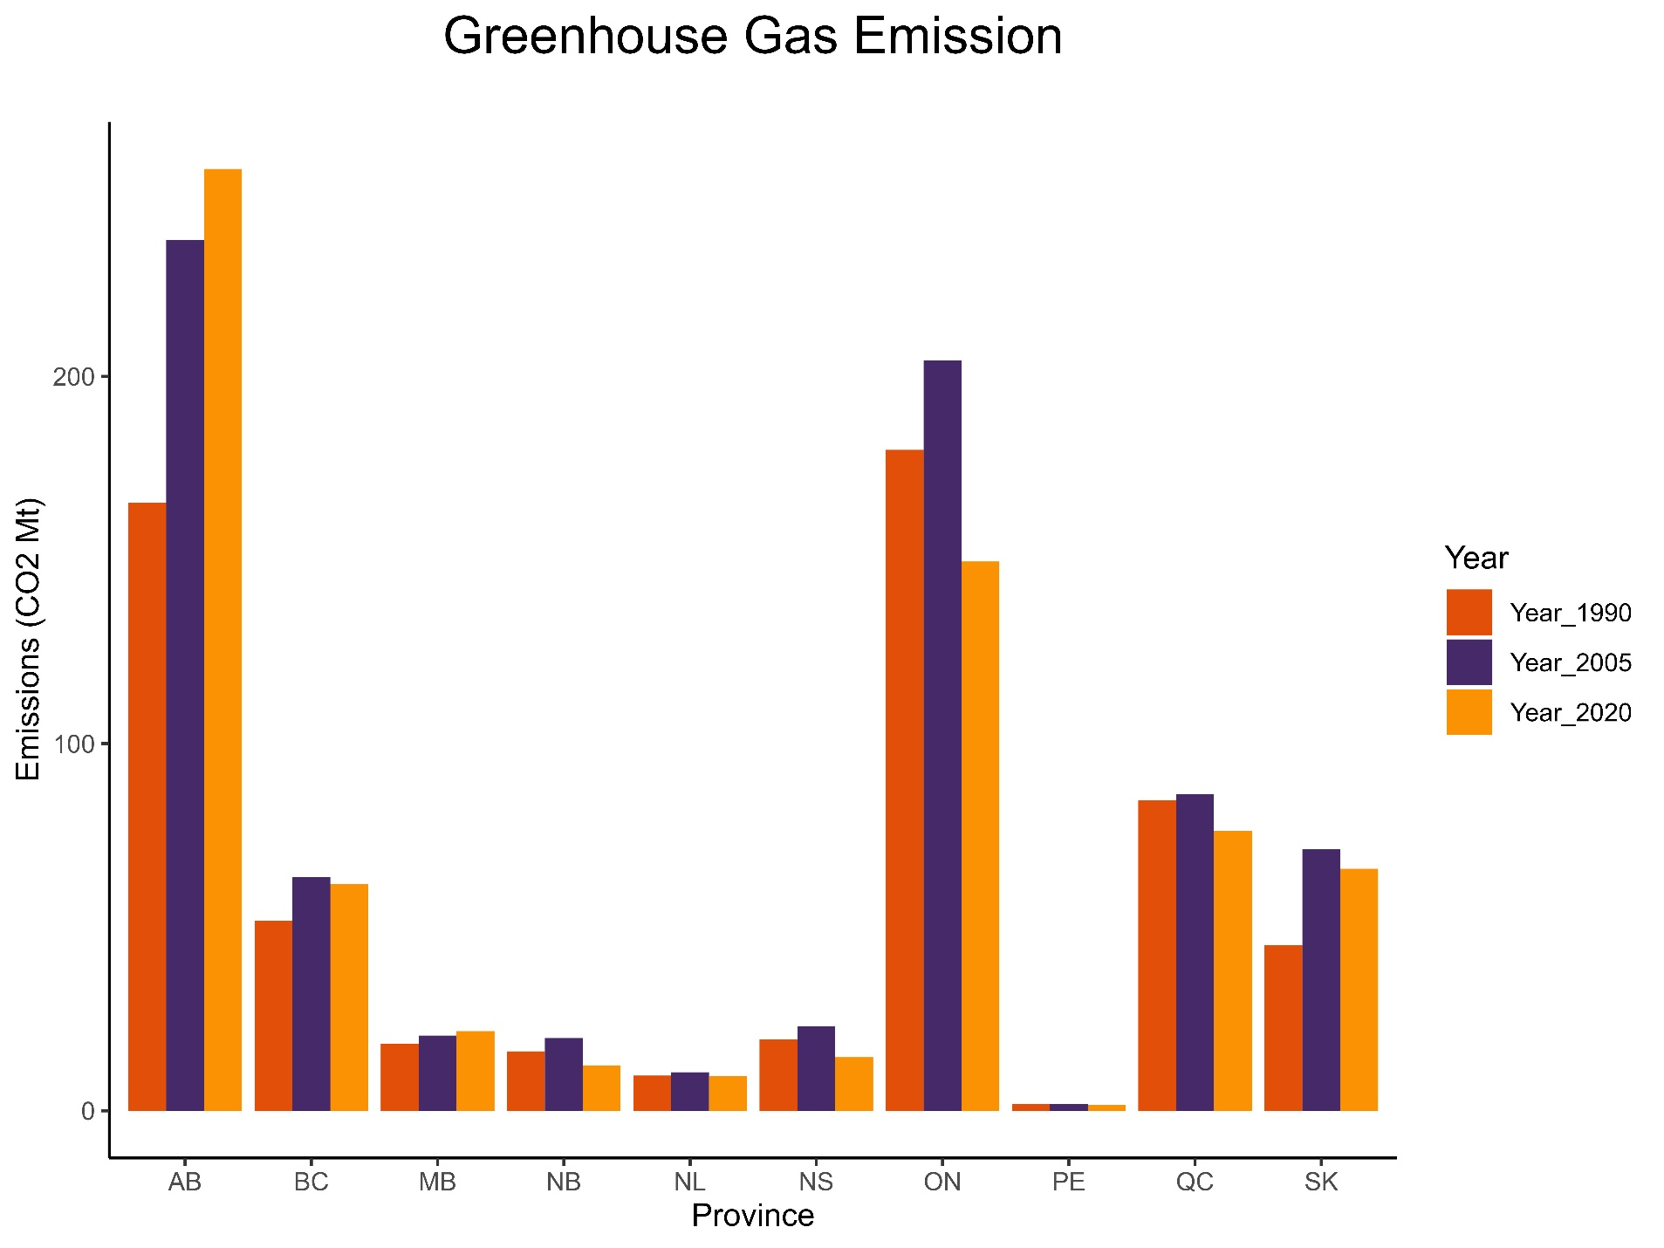

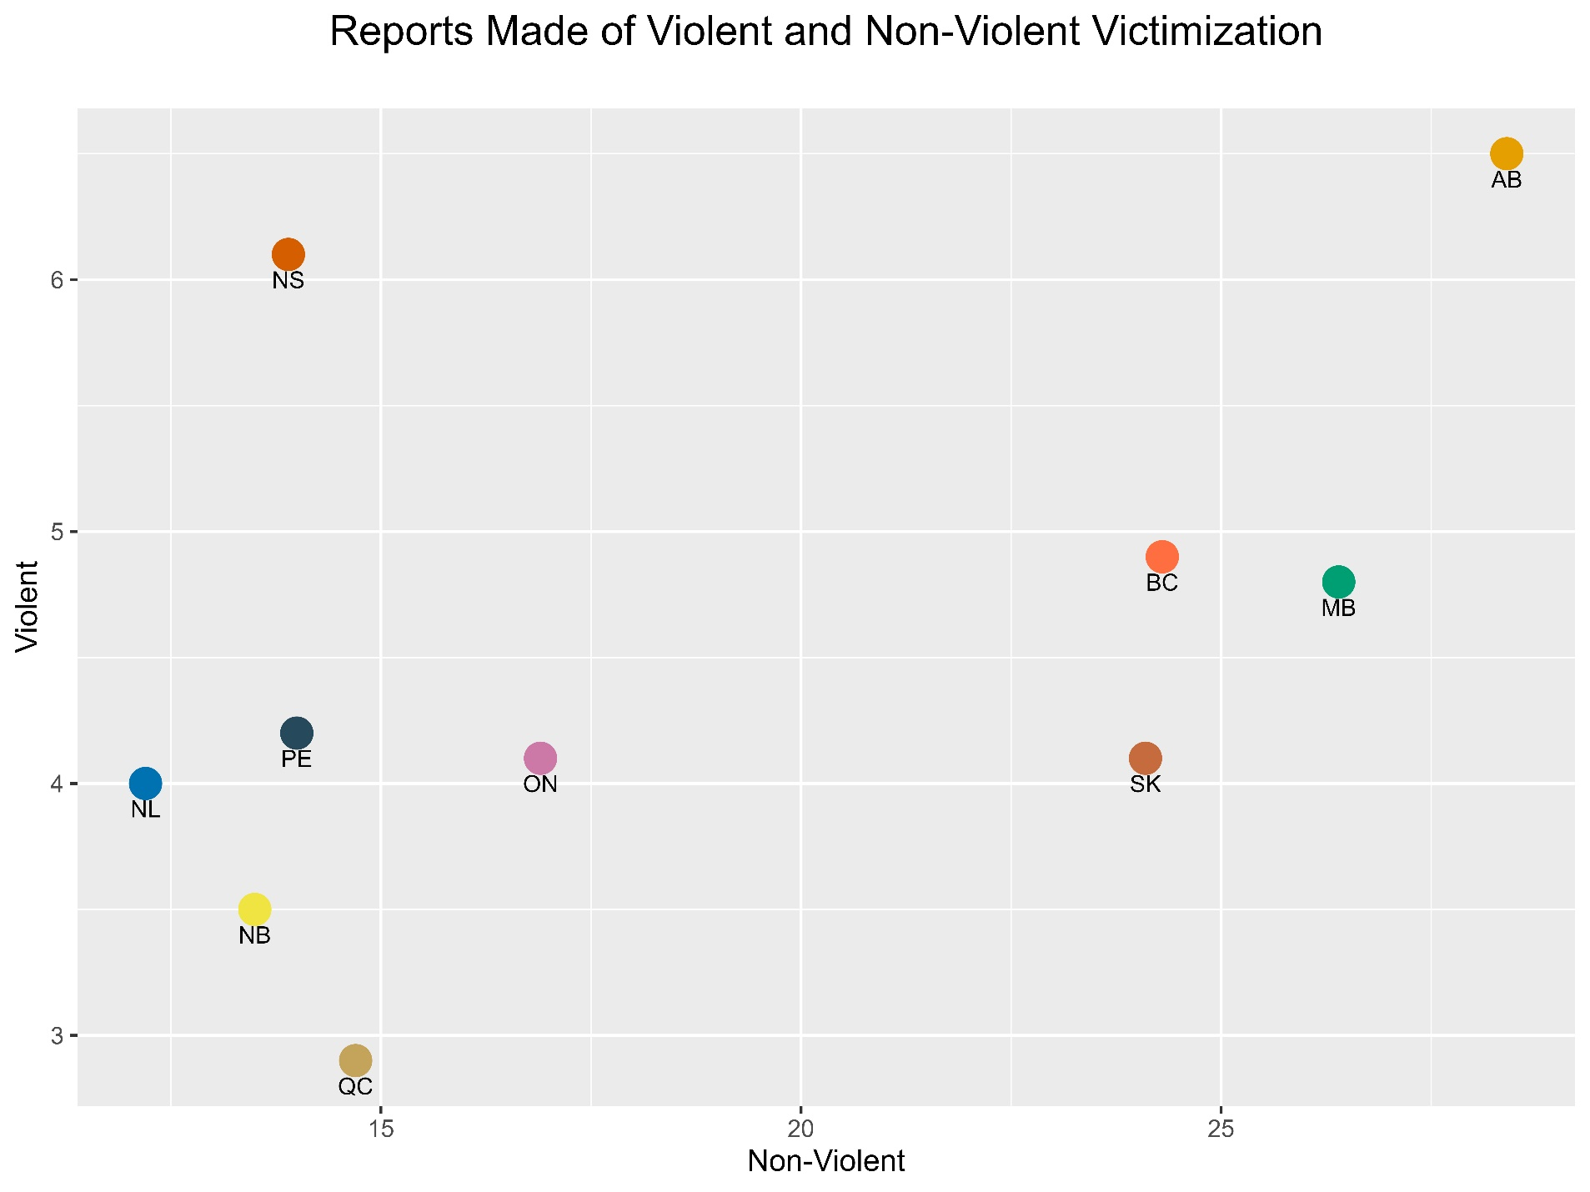

**Canada of Life - Infograph**

